drop table Family cascade constraints;

drop table Staff cascade constraints;

drop table Teacher cascade constraints;

drop table Class cascade constraints;

drop table Result cascade constraints;

drop table Student cascade constraints;

create table Family

(FamilyID int primary key,

Father_Name varchar(20),

Mother_Name varchar(20),

Father_Phone int,

Mother_Phone int,

Home_Address varchar(20));

create table Staff

( Staff_ID int primary key,

First_Name varchar(20),

Last_Name varchar(20),

Phone_Int int,

Address varchar(20),

Salary int);

create table Teacher

(Teacher_ID int,

Staff_ID int,

Room_No varchar(20),

Subject varchar(20),

primary key (Teacher_ID),

foreign key (Staff_ID) references Staff( Staff_ID));

create table Class

( Class_ID varchar(20),

Class_Subject varchar(20),

Teacher_ID int,

Lesson_Time varchar(20),

primary key( Class_ID),

foreign key( Teacher_ID) references Teacher(Teacher_ID));

create table Student

(Student_ID int,

First_Name varchar(20),

Last_Name varchar(20),

Birthdate varchar(20),

Phone int,

FamilyID int,

Class varchar(20),

primary key (Student_ID),

foreign key (FamilyID) references Family(FamilyID));

create table Result

(Exam varchar(20),

Student_ID int,

Class_ID varchar(20),

Exam_date date,

Mark int,

foreign key (Student_ID) references Student(Student_ID),

foreign key (Class_ID) references Class(Class_ID));

insert into Family values ( 1000, 'MR. Mokles', 'MRS. Sokles', 01029273, 01927382,' 29-Jalan-Gombak');

insert into Family values ( 1001, 'MR. Mula', 'MRS. Gula', 01024573, 01923482,' 29-Sri-Gombak');

insert into Family values ( 1002, 'MR. Gajor', 'MRS. Fojor', 01664573, 09923482,' 9-Sri-Kedah');

insert into Family values ( 1003, 'MR. Amm', 'MRS. Jamm', 44664573,77923482,' 91-Sr-Muda');

insert into Family values ( 1004, 'MR. Kola', 'MRS. Dola', 44664873,77923002,' 91-Sri-Huda');

insert into Family values ( 1005, 'MR. Bye', 'MRS. Hii', 44004873,77926602,' 21-Sri-Sylhet');

insert into Family values ( 1006, 'MR. Khai', 'MRS. Jai', 44004343,77924302,' 21-7-Noyakhali');

insert into Family values ( 1007, 'MR. Bari', 'MRS. Curry', 00004343,09924302,' 21-0-Potuakhali');

insert into Family values ( 1008, 'MR. Bari', 'MRS. Curry', 00004343,09924302,' 21-0-Hotuakhali');

insert into Family values ( 1009, 'MR. Huda', 'MRS. Nuda', 21004343,98924302,' 24-Jalan-Idaman');

insert into Family values ( 1010, 'MR. Akkas', 'MRS. Sakkas', 21009343,98924002,' 2-Jalan-Idaman');

insert into Family values ( 1011, 'MR. Jula', 'MRS. Juli', 21009343,98924002,' 12-D-Idaman');

insert into Family values ( 1012, 'MR. Kadia', 'MRS. Nadia', 21009763,98724002,' 22-E-Idaman');

insert into Family values ( 1013, 'MR. Kadia', 'MRS. Chadia', 210097667,98724002,' 45-A-Idaman');

insert into Family values ( 1014, 'MR. Dhongso', 'MRS. Bongsho', 98763453,98755502,' 45-P-KL');

insert into Family values ( 1015, 'MR. Hotasha', 'MRS. Natasha', 98763411,00755502,' 45-Putra-KL');

insert into Family values ( 1016, 'MR. Kosto', 'MRS. Nosto', 98763411,00755502,' D1-Putra-KL');

insert into Family values ( 1017, 'MR. Happy', 'MRS. Papi', 98763441,00711502,' D1-Putra-HKL');

insert into Family values ( 1018, 'MR. Chaiya', 'MRS. ChaiyaChaiya', 98763455,00711565,' 78-Putra-HKL');

insert into Family values ( 1019, 'MR. Khadok', 'MRS. Khaddo', 98769955,00710065,' 99-Putra-KL');

insert into Family values ( 1020, 'MR. Cafe', 'MRS. Bufe', 98761115,88887653,' 99-Sungai-KL');

insert into Family values ( 1021, 'MR. Bilai', 'MRS. Kilai', 98761115,88887653,' 99-Sungai-Chilling');

insert into Family values ( 1022, 'MR. Kutta', 'MRS. Vorta', 98765415,88887003,' 9-Sungai-Chilling');

insert into Family values ( 1023, 'MR. Cheyar', 'MRS. Beyar', 9870976,88887097,' D8-Sungai-Chilling');

insert into Family values ( 1024, 'MR. Dhisiya', 'MRS. Dhishum', 9811976,11887097,' D0-Sungai-Chilli');

insert into Family values ( 1025, 'MR. Ghushi', 'MRS. Thushi', 9811998,1188707,' D0-Sungai-Chilli');

insert into Family values ( 1026, 'MR. Latthi', 'MRS. Patti', 9811998,1188707,' 76-Damai');

insert into Family values ( 1027, 'MR. Thaba', 'MRS. Thabra', 9811008,1100707,' 7-Damai');

insert into Family values ( 1028, 'MR. Akash', 'MRS. Batash', 9800008,1100007,' 0-Kedah');

insert into Family values ( 1029, 'MR. Dasbin', 'MRS. Baskett', 9809878,1212007,' 89-Kedah');

insert into Family values ( 1030, 'MR. Fua', 'MRS. Furi', 9229878,1209007,' 89-Sylhet');

insert into Family values ( 1031, 'MR. Gua', 'MRS. Guri', 9229878,1209007,' 19-Sylhet');

insert into Family values ( 1032, 'MR. Kombokt', 'MRS. Bekkol', 9221178,1209807,' 16-Sylhet');

insert into Family values ( 1033, 'MR. Kagoj', 'MRS. Kholom', 0021178,1278807,' 16-Borishal');

insert into Family values ( 1034, 'MR. Mogoj', 'MRS. Mostiskko', 1121178,1270907,' 15-Borishal');

insert into Family values ( 1035, 'MR. Dhisumai', 'MRS. Dhisumaimai', 1121178,1270907,' 11-2-Borishal');

insert into Family values ( 1036, 'MR. Jama', 'MRS. Jamai', 1121178,1270907,' 11-2-Noyakhali');

insert into Family values ( 1037, 'MR. Gadha', 'MRS. Hiyal', 1121178,1270907,' 11-2-Takjasdb');

insert into Family values ( 1038, 'MR. Alu', 'MRS. Khalu', 1121008,1270707,' 11-T-Tarkov');

insert into Family values ( 1039, 'MR. Potol', 'MRS. Petla', 1101008,1670707,' 1-U-Tarkov');

insert into Family values ( 1040, 'MR. Gajor', 'MRS. Halua', 1101008,1670707,' 1-O-Wonderland');

insert into Family values ( 1041, 'MR. Murgi', 'MRS. Roast', 1101908,1600707,' 1-D-Wonderland');

insert into Family values ( 1042, 'MR. Rui', 'MRS. Murighonto', 19932400,16007071,' 1-D-Dhaka');

insert into Family values ( 1043, 'MR. Khashi', 'MRS. Kacchi', 19902400,16807071,' 1-D-PuranDhaka');

insert into Family values ( 1044, 'MR. Mash', 'MRS. Vaji', 19977400,16803371,' 1-4-PuranDhaka');

insert into Family values ( 1045, 'MR. Vat', 'MRS. Polau', 09977400,06803371,' 1-D-Damai');

insert into Staff values ( 500, 'Korola', 'Vaji', 09977400,' 1-D-Damai',5000);

insert into Staff values ( 501, 'Begun', 'Vaji', 09877400,' 1-3-Sungai',5000);

insert into Staff values ( 502, 'Morich', 'Vorta', 09877411,' D-4-Sungai',4000);

insert into Staff values ( 503, 'Chanachur', 'Muri', 09870011,' D-4-Ramai',4500);

insert into Staff values ( 504, 'Fucka', 'Chotpoti', 09330011,'1-Sungaibuloh',3500);

insert into Staff values ( 505, 'Alur', 'Chips', 09390011,'D2-Sungaibuloh',5500);

insert into Staff values ( 506, 'Lebur', 'Shorbot', 09397711,'D2-Sungai',4500);

insert into Staff values ( 507, 'Vapa', 'Pitha', 09397711,'D2-Keluar',5000);

insert into Staff values ( 508, 'Hutki', 'Shira', 09307711,'D2-Sylhet',4000);

insert into Staff values ( 509, 'Lacchi', 'Shemai', 1307711,'D2-Bonoful',4500);

insert into Staff values ( 510, 'Porota', 'Mangsho', 1307711,'2-Llakhal',4500);

insert into Teacher values ( 100, 500, '2-D-12', 'English');

insert into Teacher values ( 101, 501, '2-E-2', 'Math');

insert into Teacher values ( 102, 502, '1-A-4', 'Biology');

insert into Teacher values ( 103, 503, '1-B-2', 'Science');

insert into Teacher values ( 104, 504, '3-E-3', 'Geography');

insert into Teacher values ( 105, 505, '3-E-9', 'Islam');

insert into Teacher values ( 106, 506, '3-E-1', 'Histroy');

insert into Teacher values ( 107, 507, '3-C-4', 'Math');

insert into Teacher values ( 108, 508, '3-C-9', 'Science');

insert into Teacher values ( 109, 509, '1-D-9', 'English_2');

insert into Teacher values ( 110, 510, '1-D-2', 'Religion');

insert into Class values ( '3-A-S', 'Islam', 105, '10.30');

insert into Class values ( '4-A-S', 'Biology', 102, '11.30');

insert into Class values ( '5-A-S', 'Geography', 104, '1.00');

insert into Class values ( '6-A-S', 'Science', 103, '2.00');

insert into Class values ( '7-A-S', 'History', 106, '3.00');

insert into Class values ( '8-A-S', 'English', 100, '4.00');

insert into Class values ( '1-B-S', 'Islam', 105, '9.00');

insert into Class values ( '2-B-S', 'English_2', 109, '10.00');

insert into Class values ( '3-B-S', 'Math', 107, '11.00');

insert into Class values ( '4-B-S', 'Religion', 110, '12.00');

insert into Class values ( '5-B-S', 'Science', 110, '2.30');

insert into Class values ( '6-B-S', 'Geography', 104, '3.30');

insert into Student values ( 001, 'Jibon', 'Moron',('20-DEC-2000'), 01987653,1000,8);

insert into Student values ( 002, 'Prem', 'Valobasha',('23-FEB-2001'), 01980653,1001,5);

insert into Student values ( 003, 'Thash', 'Thus',('23-JAN-2003'), 01980653,1002,2);

insert into Student values ( 004, 'Uri', 'Babare',('12-JUN-2000'), 01980053,1003,8);

insert into Student values ( 005, 'Bapre', 'Bap',('30-JUN-2002'), 01989053,1004,6);

insert into Student values ( 006, 'Vavago', 'Vava',('30-SEP-2005'), 01980053,1005,1);

insert into Student values ( 007, 'Khida', 'Lagse',('12-OCT-1999'), 06380053,1006,8);

insert into Student values ( 008, 'Khaite', 'Ja',('12-APR-2001'), 01380053,1006,7);

insert into Student values ( 009, 'Prem', 'Korum',('12-MAR-2002'), 01380053,1006,6);

insert into Student values ( 010, 'Hasaili', 'Mama',('19-SEP-2003'), 01389953,1007,5);

insert into Student values ( 011, 'Iss', 'KotoShokh',('21-DEC-2005'), 01389953,1008,3);

insert into Student values ( 012, 'Vallage', 'Na',('22-JUL-2004'), 01311993,1010,1);

insert into Student values ( 013, 'Mori', 'Jamu',('03-FEB-2001'), 01311993,1010,6);

insert into Student values ( 014, 'Fifa', 'Khelbi',('02-JAN-2004'), 01311993,1010,4);

insert into Student values ( 015, 'Chol', 'Hoyejak',('02-JUN-2003'), 01311993,1015,4);

insert into Student values ( 016, 'Chol', 'Hoyejak',('02-JUN-2003'), 01311993,1015,4);

insert into Student values ( 017, 'Shala', 'Nub',('02-JUN-2001'), 01311293,1020,6);

insert into Student values ( 018, 'Vora', 'Khabi',('09-OCT-2001'), 13311293,1023,7);

insert into Student values ( 019, 'Tui', 'Nuub',('19-OCT-2003'), 13311293,1025,3);

insert into Student values ( 020, 'Lojja', 'Nai',('23-JAN-2002'), 1331293,1027,1);

insert into Student values ( 021, 'Hehe', 'Hala',('22-FEB-2005'), 1331883,1029,2);

insert into Student values ( 022, 'Emne', 'VoraKhaisos',('22-MAY-1998'), 1300883,1032,8);

insert into Student values ( 023, 'Bal', 'Sal',('22-MAY-2000'), 1303483,1033,7);

insert into Student values ( 024, 'Chol', 'Khamu',('10-JUN-2006'), 1303483,1033,1);

insert into Student values ( 025, 'Eto', 'Khaikhai',('10-JUL-2005'), 1345483,1038,2);

insert into Student values ( 026, 'Thabra', 'Dia',('12-DEC-2006'), 1345483,1038,3);

insert into Student values ( 027, 'Dat', 'Falaidimu',('30-May-2001'), 1345483,1041,6);

insert into Student values ( 028, 'Bujhsos', 'Ni',('31-MAR-2002'), 1342283,1031,4);

insert into Student values ( 029, 'Bujhsos', 'Ni',('05-APR-2002'), 1342993,1042,2);

insert into Student values ( 030, 'Ki', 'Vabos',('08-SEP-2001'), 0042993,1044,1);

insert into Student values ( 031, 'Tar', 'Chokh',('02-FEB-2004'), 0042211,1035,7);

insert into Student values ( 032, 'Totlas', 'Ken',('12-DEC-2001'), 0042111,1037,1);

insert into Student values ( 033, 'Koitesi', 'Beta',('12-JUN-2006'), 0042111,1031,2);

insert into Student values ( 034, 'Dekhe', 'Dioyana',('15-JUN-2005'), 9942111,1024,3);

insert into Student values ( 035, 'Muri', 'Kha',('11-JUN-2001'), 9942111,1024,8);

insert into Student values ( 036, 'Uri', 'Mama',('02-DEC-2004'), 01311993,1013,3);

insert into Student values ( 037, 'Maf', 'Kor',('19-SEP-2003'), 01389953,1008,5);

insert into Student values ( 038, 'Vaglam', 'Ami',('30-JUN-2002'), 01989053,1004,6);

insert into Result values ('Final',001,'4-A-S',('30-JUN-2019'),75);

insert into Result values ('Final',002,'4-A-S',('30-JUN-2019'),70);

insert into Result values ('Final',003,'4-A-S',('30-JUN-2019'),66);

insert into Result values ('Final',004,'4-A-S',('30-JUN-2019'),96);

insert into Result values ('Final',005,'4-A-S',('30-JUN-2019'),89);

insert into Result values ('Final',006,'4-A-S',('30-JUN-2019'),66);

insert into Result values ('Final',007,'4-A-S',('30-JUN-2019'),69);

insert into Result values ('Final',008,'4-A-S',('30-JUN-2019'),71);

insert into Result values ('Final',009,'4-A-S',('30-JUN-2019'),75);

insert into Result values ('Final',010,'6-A-S',('30-JUN-2019'),59);

insert into Result values ('Final',011,'6-A-S',('30-JUN-2019'),54);

insert into Result values ('Final',012,'6-A-S',('30-JUN-2019'),49);

insert into Result values ('Final',013,'6-A-S',('30-JUN-2019'),91);

insert into Result values ('Final',013,'3-B-S',('29-JUN-2019'),80);

insert into Result values ('Final',014,'3-B-S',('29-JUN-2019'),74);

insert into Result values ('Final',015,'3-B-S',('29-JUN-2019'),61);

insert into Result values ('Final',016,'3-B-S',('29-JUN-2019'),69);

insert into Result values ('Final',017,'3-B-S',('29-JUN-2019'),74);

insert into Result values ('Final',018,'3-B-S',('29-JUN-2019'),66);

insert into Result values ('Final',019,'3-B-S',('29-JUN-2019'),99);

insert into Result values ('Final',020,'3-B-S',('29-JUN-2019'),30);

insert into Result values ('Final',021,'6-A-S',('29-JUN-2019'),75);

insert into Result values ('Final',022,'6-A-S',('29-JUN-2019'),80);

insert into Result values ('Final',023,'6-A-S',('29-JUN-2019'),70);

insert into Result values ('Final',024,'6-A-S',('29-JUN-2019'),53);

insert into Result values ('Final',023,'6-A-S',('29-JUN-2019'),56);

insert into Result values ('Final',030,'6-A-S',('29-JUN-2019'),71);

insert into Result values ('Final',030,'3-A-S',('28-JUN-2019'),72);

insert into Result values ('Final',030,'4-A-S',('27-JUN-2019'),90);

insert into Result values ('Final',030,'8-A-S',('28-JUN-2019'),81);

insert into Result values ('Final',030,'3-B-S',('30-JUN-2019'),86);

insert into Result values ('Final',030,'5-B-S',('25-JUN-2019'),69);

insert into Result values ('Final',030,'2-B-S',('26-JUN-2019'),83);

**PROOCEDURES**

To get students father’s and mother’s name by inserting family id:

create or replace procedure pro1(c_family_ID family.familyid%TYPE) IS

fathername varchar(20);

mothername varchar(20);

phone int;

home_add varchar(20);

BEGIN

select father_name,mother_name,father_phone,home_address into fathername,mothername,phone,home_add

from family

where c_family_ID=familyid;

dbms_output.put_line('Father Name: '||fathername);

dbms_output.put_line('Mother Name: '||mothername);

dbms_output.put_line('Phone Int: '||phone);

dbms_output.put_line('Address: '||home_add);

end;

/

--ANONYMOUS BLOCK

--===========================

ACCEPT famID PROMPT 'Enter the family ID: '

begin

pro1('&famID');

dbms_output.put_line('THe data is successfully entered.');

end;

/

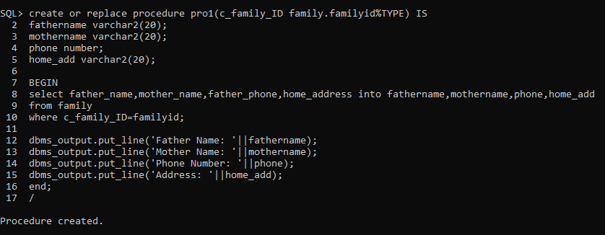

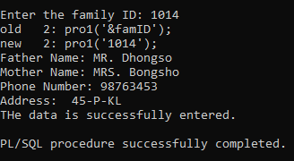

Inserting a new row in staff table:

create or replace procedure newval

(s_staff_id staff.staff_id%TYPE,

s_first_name staff.first_name%TYPE,

s_last_name staff.last_name%TYPE,

s_staff_phone staff.phone_int%TYPE,

s_address staff.address%TYPE,

s_salary staff.salary%TYPE

) IS

BEGIN

INSERT INTO staff (staff.staff_id,staff.first_name,staff.last_name,staff.phone_int,staff.address,staff.salary)

VALUES (s_staff_id,s_first_name,s_last_name,s_staff_phone,s_address,s_salary);

DBMS_OUTPUT.PUT_LINE('Data successfully added');

END;

/

--ANONYMOUS BLOCK

--===========================

ACCEPT s_staff_id prompt 'ENTER Staff ID: '

ACCEPT s_first_name prompt 'ENTER FIRST NAME: '

ACCEPT s_last_name prompt 'ENTER LAST NAME: '

ACCEPT s_staff_phone prompt 'ENTER PHONE NO: '

ACCEPT s_address prompt 'ENTER ADDRESS: '

ACCEPT s_salary prompt 'ENTER SALARY: '

BEGIN

newval('&s_staff_id','&s_first_name','&s_last_name','&s_staff_phone','&s_address','&s_salary');

END;

/

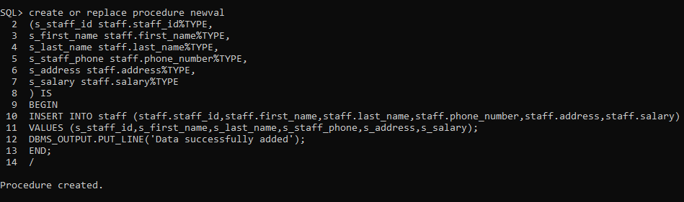 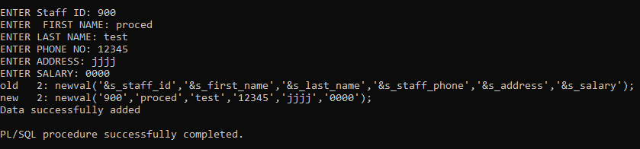

After updating Staff table:

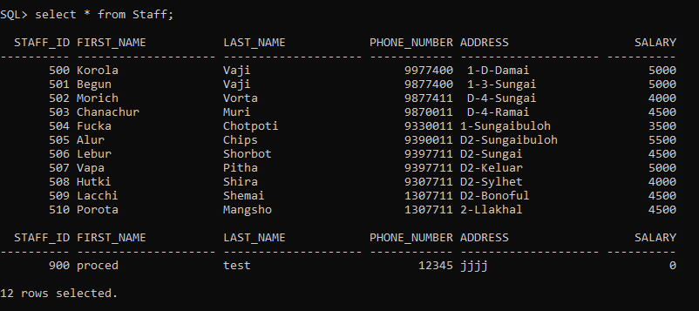

**FUNCTIONS:**

Giving students result by inserting student id and class id:

CREATE OR REPLACE FUNCTION grading

(stud_id in int,c_id in varchar2)

return varchar2

is

m_mark int;

grade varchar2(2);

BEGIN

select mark into m_mark

from result

where stud_id=result.student_id

AND c_id=result.class_id;

if m_mark>0 AND m_mark<49 then grade:='F';

elsif m_mark>=50 AND m_mark<=59 then grade:='C';

elsif m_mark>=60 AND m_mark<=69 then grade:='B';

elsif m_mark>=70 AND m_mark<=79 then grade:='A-';

elsif m_mark>=80 AND m_mark<=100 then grade:='A';

end if;

return(grade);

end;

/

--ANONYMOUS BLOCK

--===========================

ACCEPT stud_id prompt 'Enter Student ID:'

ACCEPT c_id prompt 'Enter c_id ID:'

declare

stud_id int;

c_id varchar(20);

BEGIN

stud_id:=&stud_id;

c_id:=&c_id;

DBMS_OUTPUT.put_line('The grade is '||grading(stud_id,c_id));

END;

/

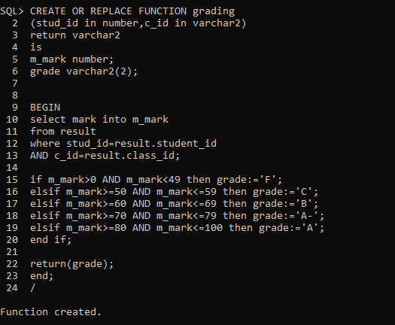

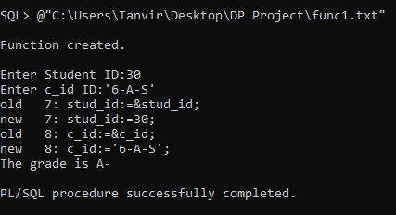

Get how many students in a class by giving class id:

CREATE OR REPLACE FUNCTION tota_stud

(cls_id in varchar2)

return int

is

s_id int;

BEGIN

select count(student_id) into s_id

from result

where cls_id=result.class_id;

return(s_id);

end;

/

--ANONYMOUS BLOCK

--===========================

ACCEPT cls_id prompt 'Enter Class ID:'

declare

cls_id varchar(20);

BEGIN

cls_id:=&cls_id;

DBMS_OUTPUT.put_line('Total students in this course are '||tota_stud(cls_id));

END;

/

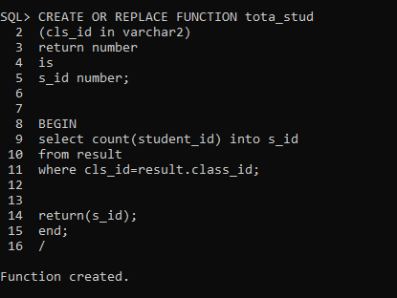

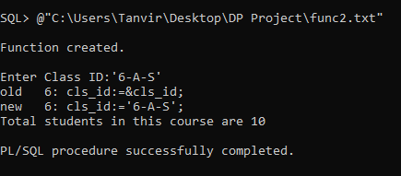

**IMPLICIT CURSOR:**

To delete specific student details by giving student id:

BEGIN

DELETE FROM result

where student_id=030;

IF SQL%NOTFOUND THEN

DBMS_OUTPUT.PUT_LINE('No maching record');

ELSIF SQL%FOUND then DBMS_OUTPUT.PUT_LINE('DATA Successfully deleted');

END IF;

END;

/

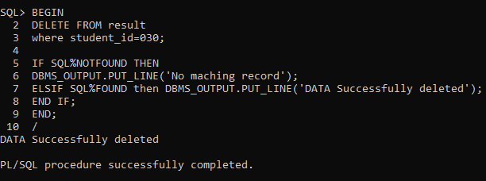

**EXPLICIT CURSOR:**

Get specific students exam results by giving student id:

Declare

r_student_id result.student_id%TYPE;

r_class_id result.class_id%TYPE;

r_exam_date result.exam_date%TYPE;

r_mark result.mark%TYPE;

CURSOR result_cursor IS

select student_id,class_id,exam_date,mark

from result;

BEGIN

OPEN result_cursor;

LOOP

FETCH result_cursor into r_student_id,r_class_id,r_exam_date,r_mark;

EXIT WHEN result_cursor%ROWCOUNT >5 OR

result_cursor%NOTFOUND;

DBMS_OUTPUT.PUT_LINE

(to_char(r_student_id)||' '||r_class_id||' '||r_exam_date||' '||r_mark);

END LOOP;

CLOSE result_cursor;

END;

/

